**Coding Assesment:**

**1.Explain Python Module with examples  
a.Import module in Python  
b.Renaming the Python module**

1. **Python Module:**

In Python, a module is basically a file containing Python code. It can define functions, classes, and variables that you can reuse in other Python files by importing them.

Createing a python module:

To import a module in python first we need to create a module with some name and then we need to use import statement to import the created module.

Import module in python:

We can import the functions, and classes defined in a module to another module using import statement in other Python source file.

* Initially I created a module named addsub.py to perform operations like addition and substraction

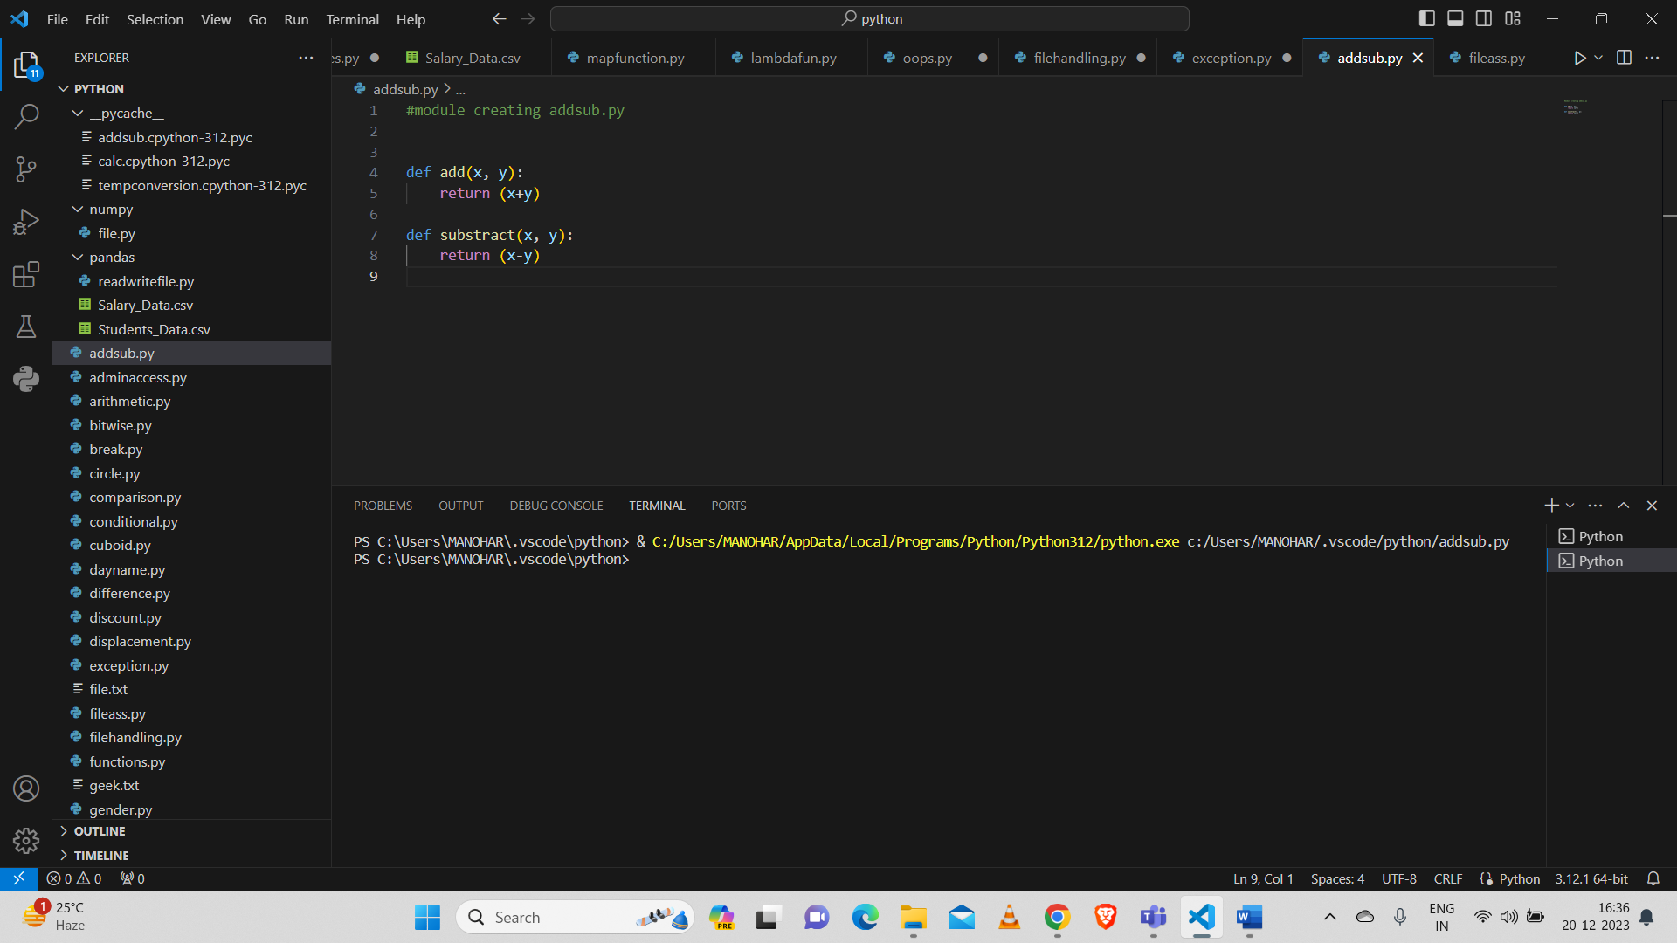

And then using import statement imported addsub.py module in python and performed addition operation.

Here imported addsub.py module and performed addition operation for numbers 10 and 2.

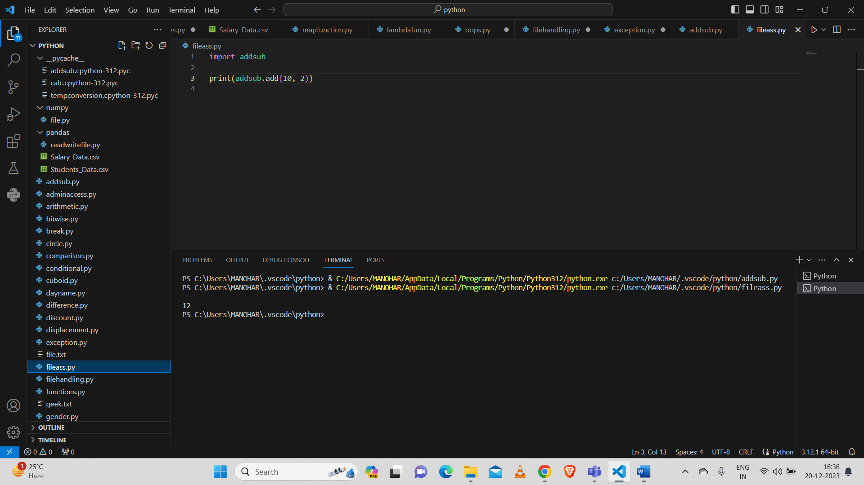

And also performed Substraction operation.

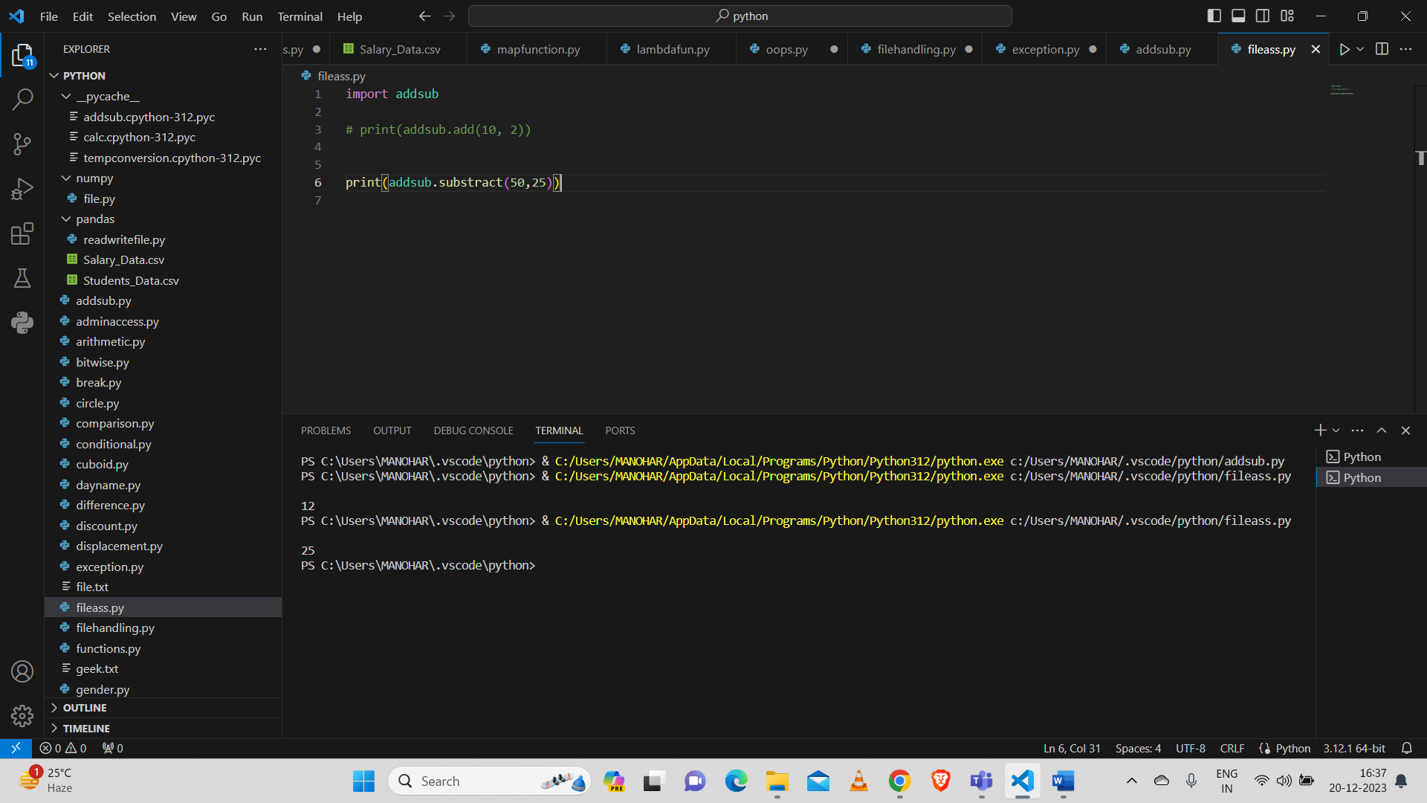

Imported sqrt and factorial from math module:

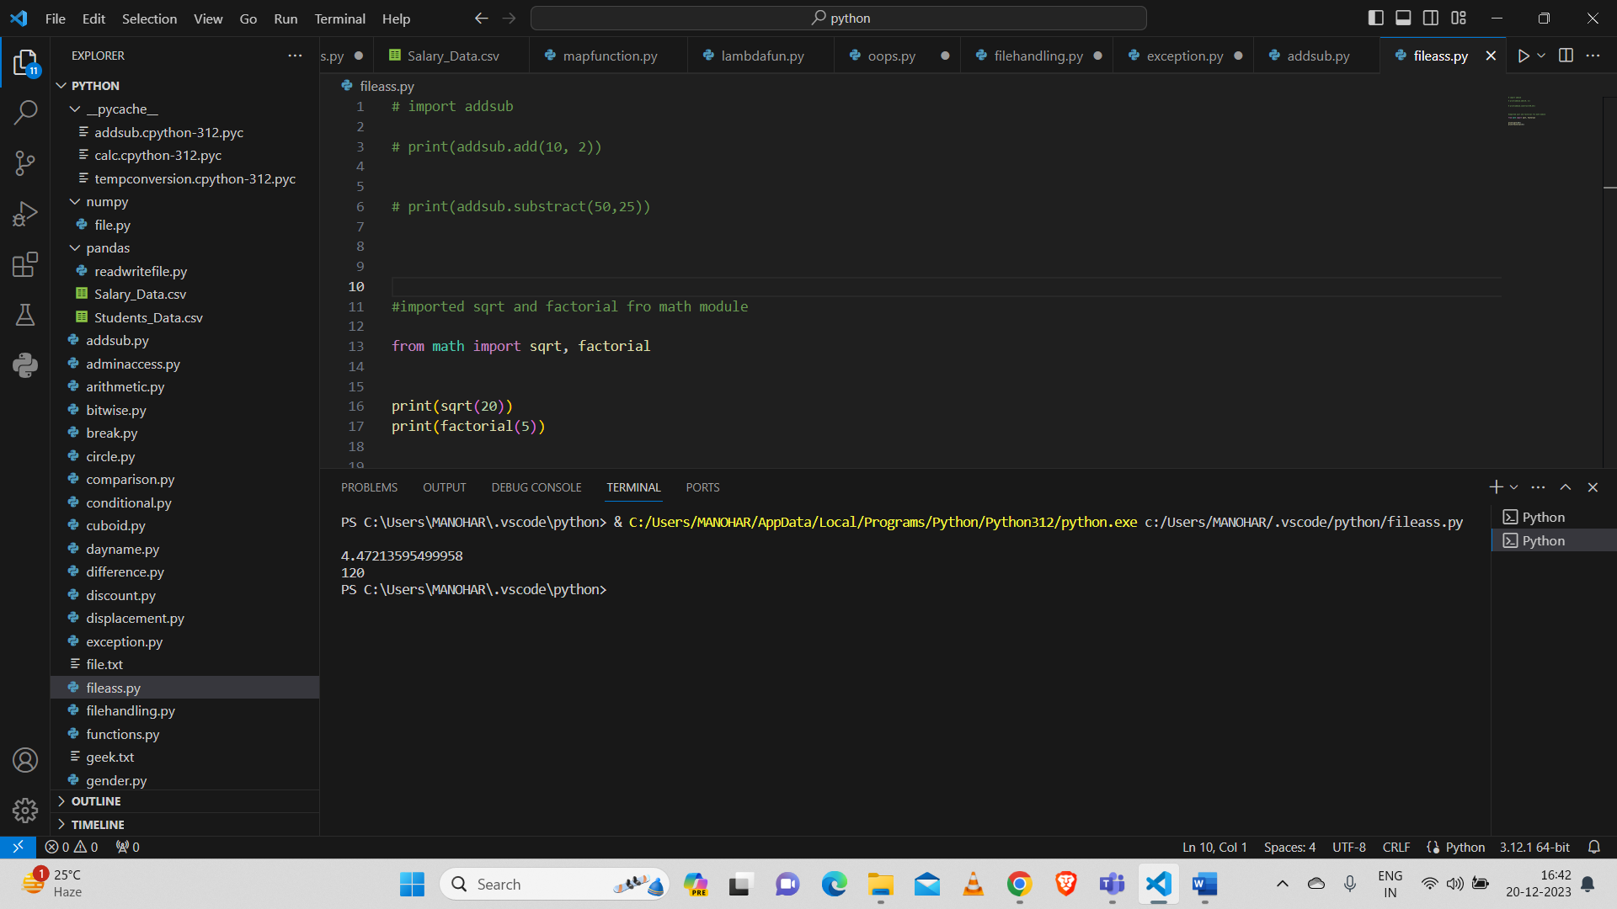

1. **Renaming the python module:**

We can rename the module while importing the module

Renamed module named addsub.py as ads while importing the module and performed addition operation on two numbers.

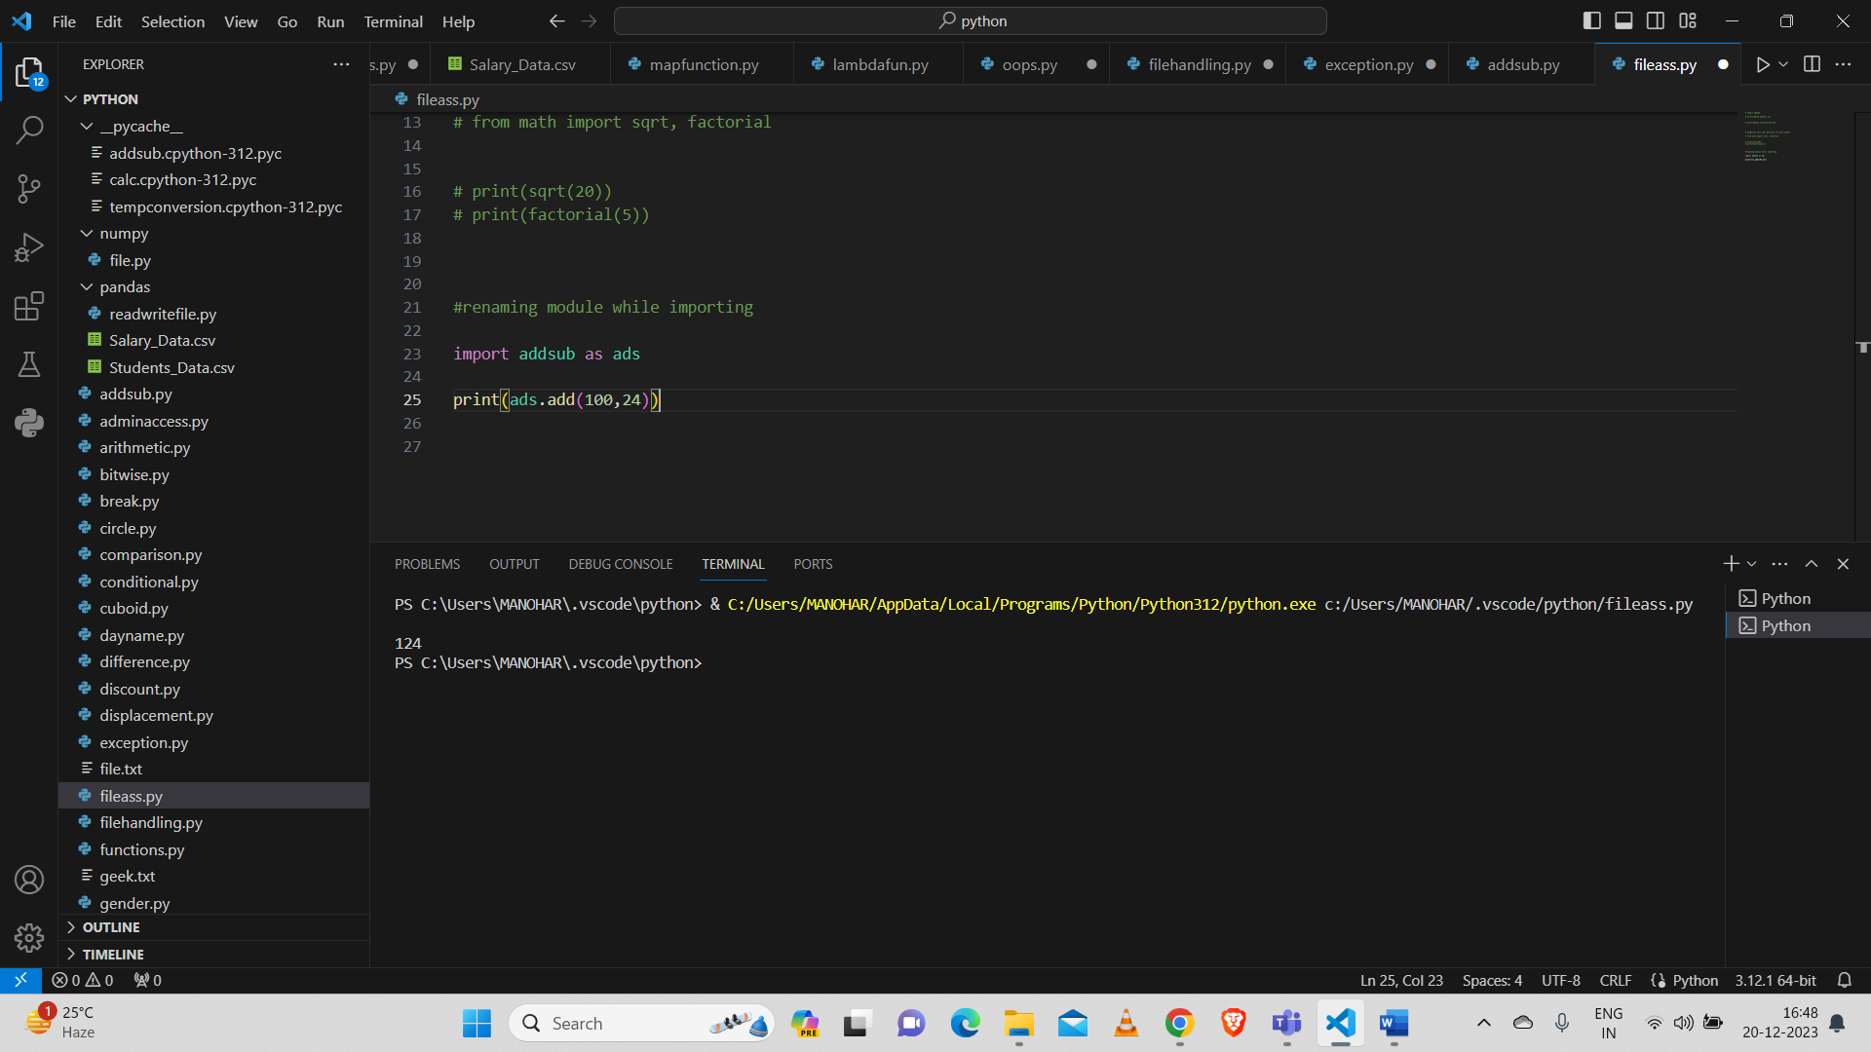

**2.Explain Pandas and numpy using Examples in PYTHON**

**Pandas:**

Pandas is a Python library used for working with data sets. And it has functions for analyzing, cleaning, exploring, and manipulating data. Pandas allows us to analyze big data.

Imported pandas as pd and then reading data from .csv file named Students_Data.csv

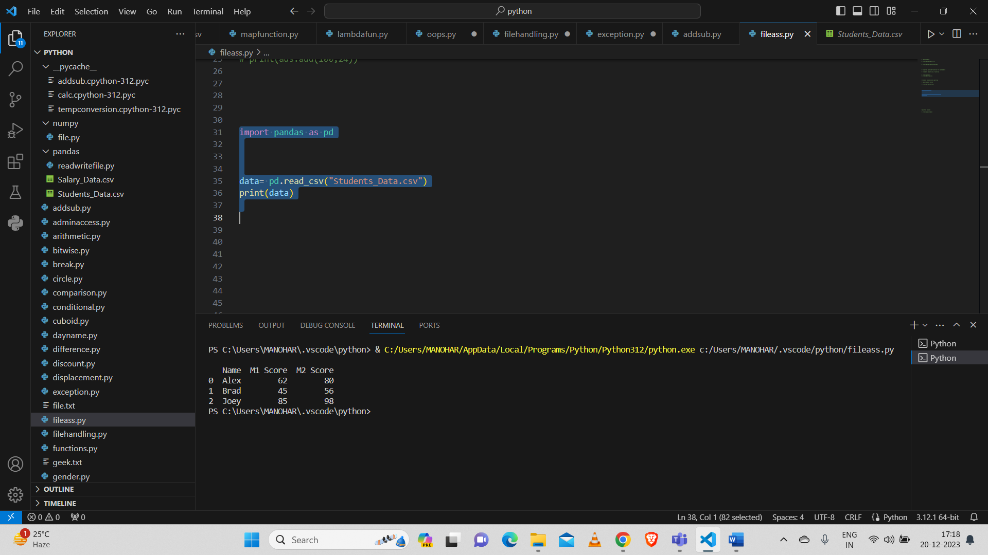

And also printing the columns in the Students_Data.csv file.

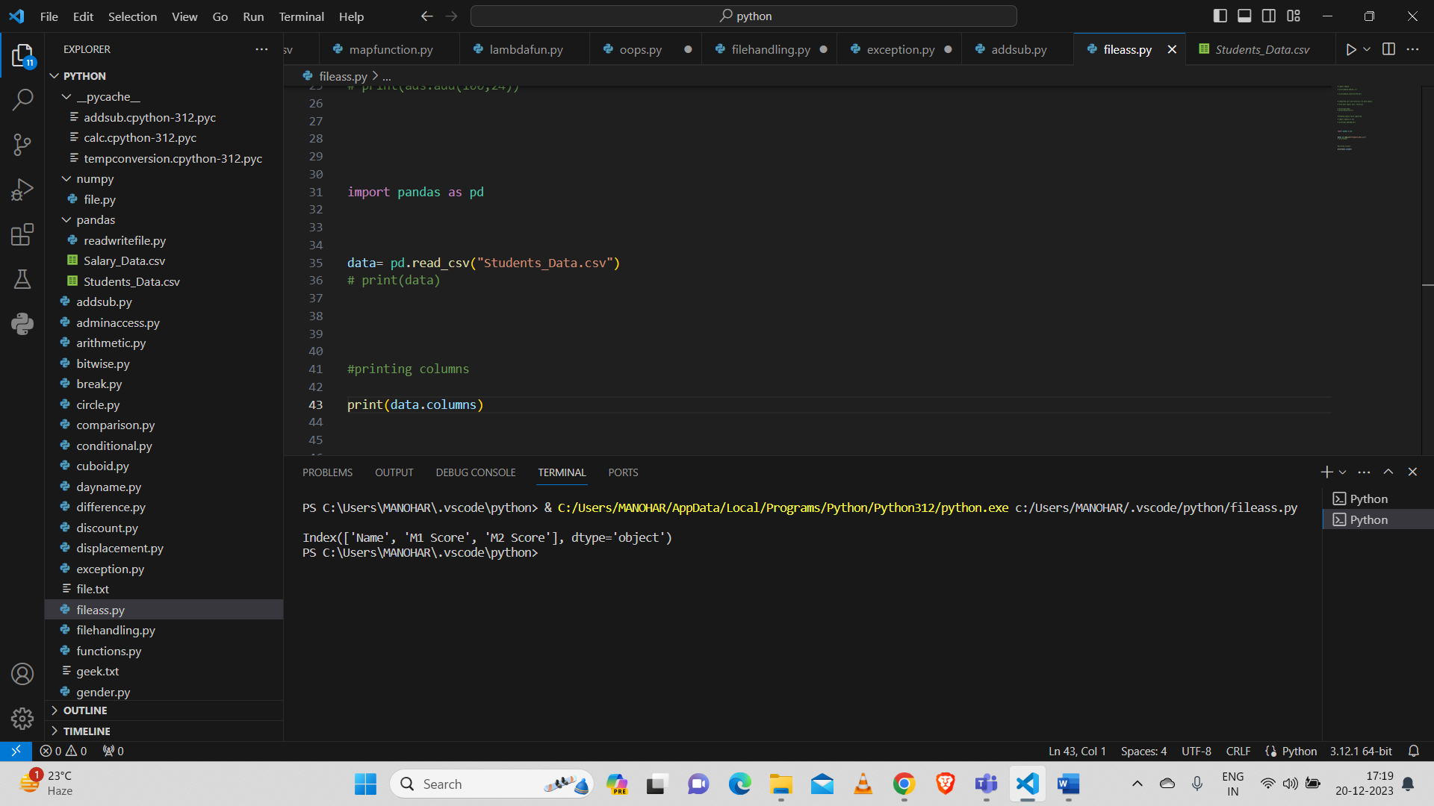

**Numpy:**

Numpy is used for processing arrays and working with arrays. It is open source software.

Imported numpy as np and created array using list with data type of int.

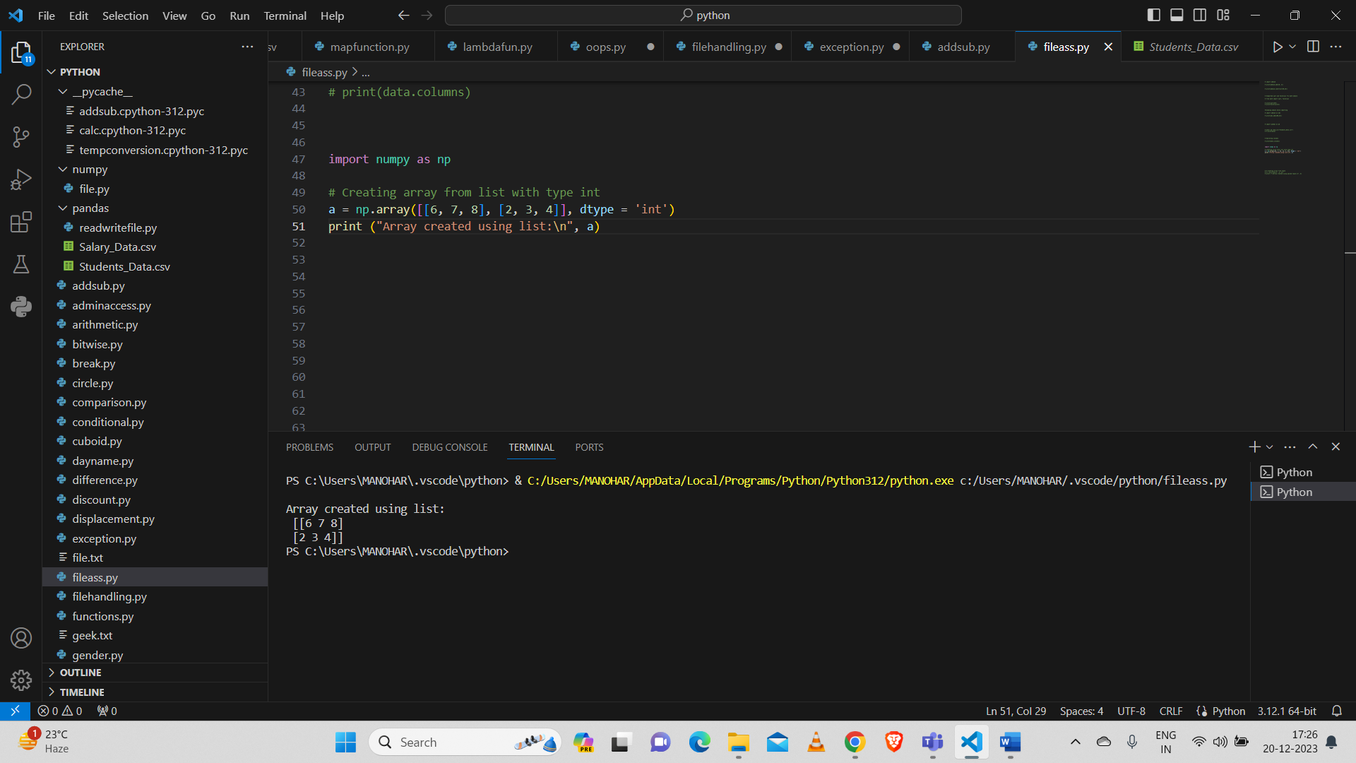

And created an array with data type of float.

Here while using float data type we got output separated by ‘.’

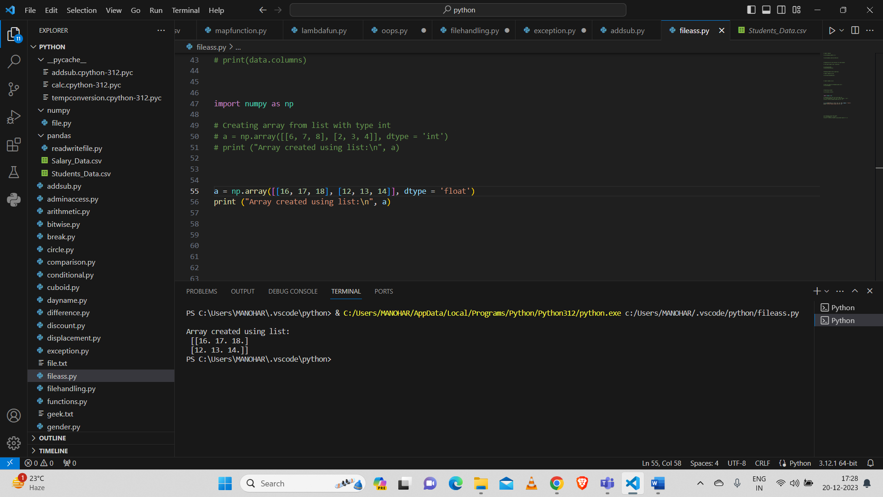

And I created array using tuple.

